Last updated 30 March 2020
CLAIMING CENTRELINK DURING COVID-19
A STEP-BY-STEP GUIDE

This factsheet contains information on how to claim a Centrelink payment if you are affected by COVID-19.

To find out if you are eligible for a payment see our factsheet on COVID-19 & Centrelink.

This fact sheet is divided into 2 parts:

- You should go to Part A if you have never applied for a Centrelink payment before.
- You should go to Part B if you have applied for Centrelink payment before.

Before you begin, you will need to log into your myGov account
A myGov account allows you to access government services online, including Centrelink, the Australian Tax Office and Medicare.

If you don't have a myGov account, you can find a step-by-step guide to creating one here: https://www.servicesaustralia.gov.au/individuals/online-help/create-mygov-account.

Part A - Claiming Centrelink payments for the first time

Registering an "intention to claim" Centrelink payments

Centrelink is currently receiving a high volume of calls and visits to their centres. As a result, the government is now allowing people to register an "intention to claim" Centrelink payments through their myGov account.

This means that rather than completing a full claim straight away, you can register an intention to claim quickly online and do not need to visit a service centre. You can then complete a full claim later, and if you are approved you will receive payments backdated from the date you registered your intention to claim.

This step-by-step guide includes details on how to register your intention to claim.

Step 1: Link your myGov account with services

If your myGov account is already linked with either Medicare or the Australian Tax office, go to Step 2.

You will need to link your myGov account with either Medicare or the Australian Tax Office to register your intention to claim Centrelink payments.

You can find guides on how to link services to your myGov account here: https://www.servicesaustralia.gov.au/individuals/online-help/mygov.

Step 2: Register your ‘Intention to Claim’

On the myGov home page, the box below will be displayed with a button stating "Register intention to claim".

Once you have registered your intention to claim, any payments you receive will be backdated to the date you registered, even if you compete your application at a later date.

Centrelink will be in contact to let you know the next step to make your claim.

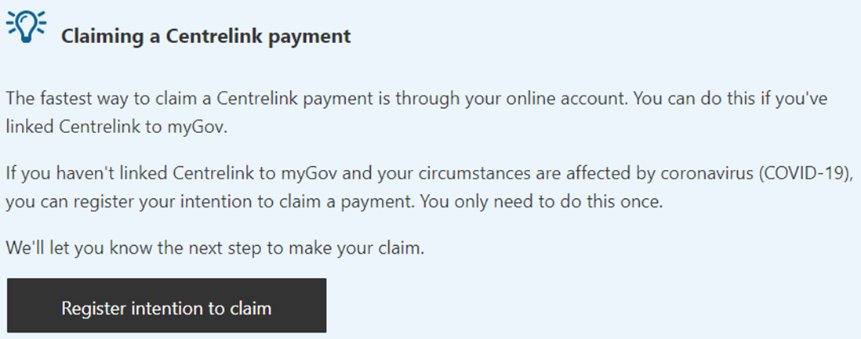

Step 3: Confirm your identity and get a CRN and a linking code
Before you set up an online account with Centrelink, you will need to confirm your identity.

Centrelink now allows people to call the Job Seeker line on 132 850 or the Youth Allowance line on 132 490 to confirm their identity on the phone. This means that you do not need to go into a service centre.

Centrelink is experiencing a high volume of calls at the moment, and you may have to hold for a long time.

Centrelink will ask for documents such as a current Australian driver licence or passport. You can find more details on documents which can be used to confirm your identity here.

Once you have verified your identity, Centrelink will give you a Customer Reference Number ('CRN') and a linking code.

Step 4: Link Centrelink to your myGov account
You now need to link Centrelink to your myGov account.

In the "Services" tab on myGov, there are multiple ways to do this (see below). One way is to use the linking code and CRN from Step 3.

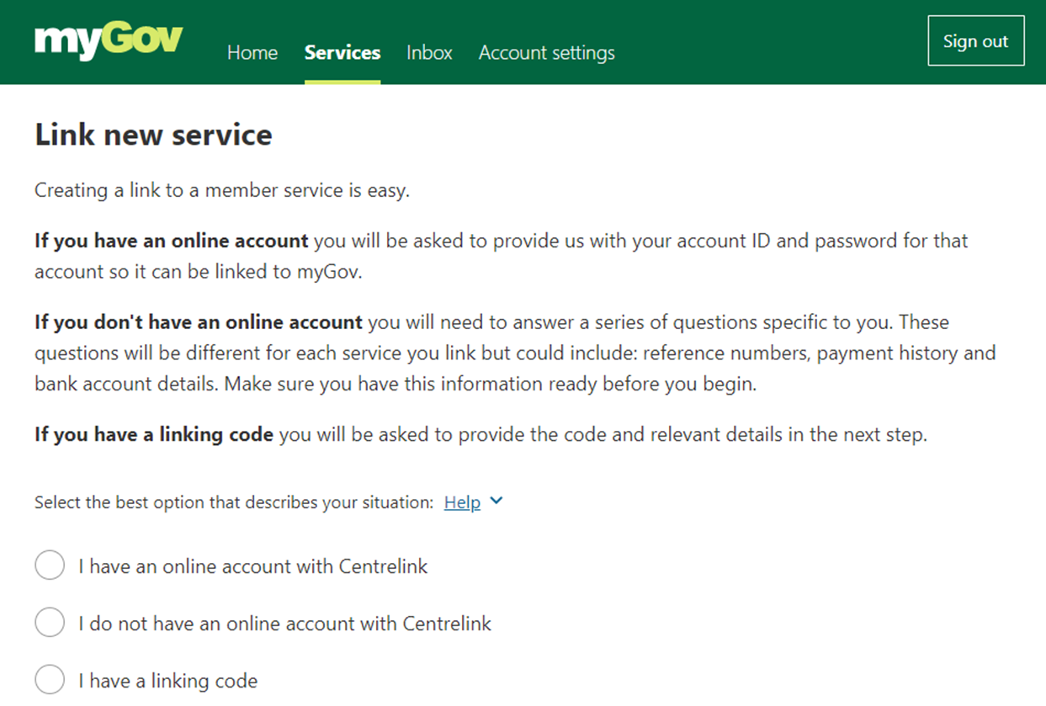

Step 5: Make a claim through your Centrelink account
You can make claims for payments through your Centrelink account.
Select Payments and Claims from the menu, then Claims, then Make a claim.
You will need to select the category that best describes your circumstance.

You will be asked a number of questions and required to give Centrelink certain documents relating to areas including your finances, employment and relationships. There are more details of the documents Centrelink may require on the Services Australia website: https://www.servicesaustralia.gov.au/individuals/topics/supporting-documents-your-centrelink-claim/45521.

As part of your online claim, you will book a phone appointment with Centrelink.

Centrelink will let you know the result of your claim through your myGov Inbox, Centrelink online account, the Centrelink app or physical post.

When you are applying for Jobseeker Payment and Youth Allowance Jobseeker, you will be required to:

- make an initial declaration about your identity, residency status and income
- if you are a worker, make a declaration that you have been made redundant or had your hours reduced (including to zero) as a result of the economic downturn due to COVID-19
- if you are a sole trader, make a declaration that your business has been suspended or had turnover reduced significantly

If you pay rent, you should also declare the amount you pay to qualify for Rent Assistance.

A number of previous requirements for claiming the payments will be removed temporarily, including the requirements for:

- Employment Separation Certificates, proof of rental arrangements and verification of relationship status
- Job Seeker Classification Instrument assessment for those people who have recently left jobs and are therefore job ready
- Making an appointment with an employment service provider before you can be paid

Part B - Claiming Centrelink payments when you have applied for a Centrelink payment before

Step 1: Link your myGov account to Centrelink

If your myGov account is already linked to Centrelink, go to Step 2.

You will need to link your myGov account to Centrelink.

You can find guides on how to link services to your myGov account here: https://www.servicesaustralia.gov.au/individuals/online-help/mygov.

Step 2: Register your intention to claim Centrelink payments OR start your claim now

You can now choose to either:
- register your intention to claim on the myGov Welcome screen or
- go to your Centrelink online account and start your claim now.

There are details on each option below.

Registering an "intention to claim" Centrelink payments

Centrelink is currently receiving a high volume of calls and visits to their centres. As a result, the government is now allowing people to register an "intention to claim" Centrelink payments through their myGov account.

This means that rather than completing a full claim straight away, you can register an intention to claim quickly online. You can then complete a full claim later, and if you are approved you will receive payments backdated from the date you registered your intention to claim.

You do not need to visit a service centre to register your intention to claim. You can do it through your myGov account:

On the myGov home page, the following box will be displayed with a button stating "Register intention to claim".

Once you have registered your intention to claim, any payments you receive will be backdated to the date you registered, even if you compete your application at a later date.

Centrelink will then be in contact to let you know the next step to make your claim.

Making a claim through your Centrelink account

You can make claims through your Centrelink account.
Select Payments and Claims from the menu, then Claims, then Make a claim.
You will need to select the category that best describes your circumstance.

You will be asked a number of questions and required to give Centrelink certain documents relating to areas including your finances, employment and relationships. There are more details of the documents Centrelink may require on the Services Australia website:
https://www.servicesaustralia.gov.au/individuals/topics/supporting-documents-your-centrelink-claim/45521.
As part of your online claim, you will book a phone appointment with Centrelink.

Centrelink will let you know the result of your claim through your myGov Inbox, Centrelink online account, the Centrelink app or physical post.

When you are applying for Jobseeker Payment and Youth Allowance Jobseeker, you will be required to:

- make an initial declaration about your identity, residency status and income
- if you are a worker, make a declaration that you have been made redundant or had your hours reduced (including to zero) as a result of the economic downturn due to COVID-19
- if you are a sole trader, make a declaration that your business has been suspended or had turnover reduced significantly

If you pay rent, you should also declare the amount you pay to qualify for Rent Assistance.

A number of previous requirements for claiming the payments will be removed temporarily, including the requirements for:

- Employment Separation Certificates, proof of rental arrangements and verification of relationship status
- Job Seeker Classification Instrument assessment for those people who have recently left jobs and are therefore job ready
- Making an appointment with an employment service provider before you can be paid

This factsheet does not constitute legal advice.
Please contact any of our member centres if you wish to obtain free legal advice.
Find your closest member centre at www.ejaustralia.org.au/legal-help-centrelink/.

