

**BUSHFIRE RECOVERY & CENTRELINK**

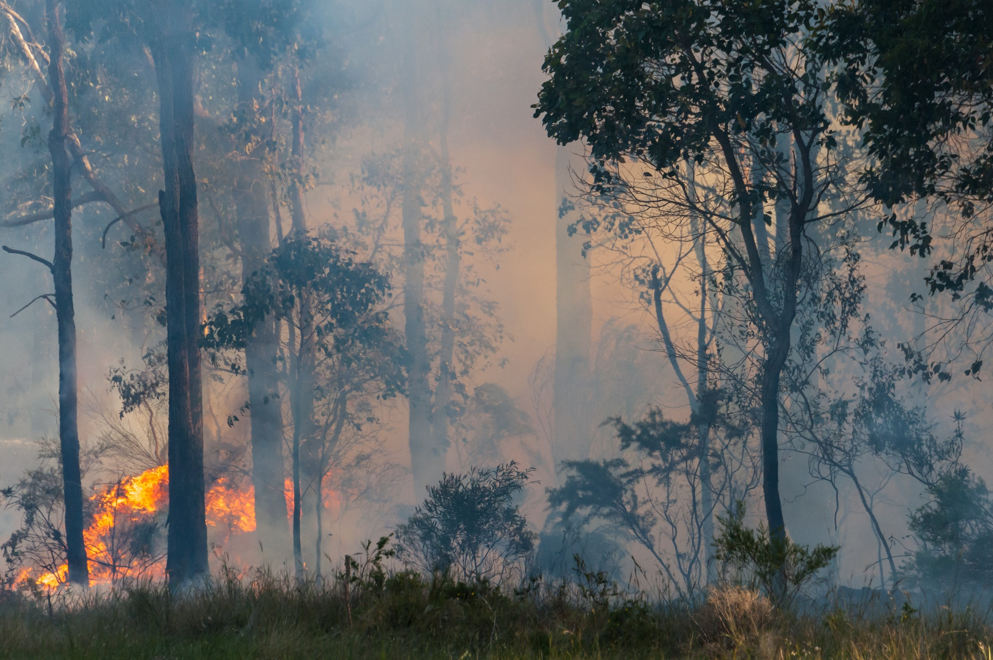

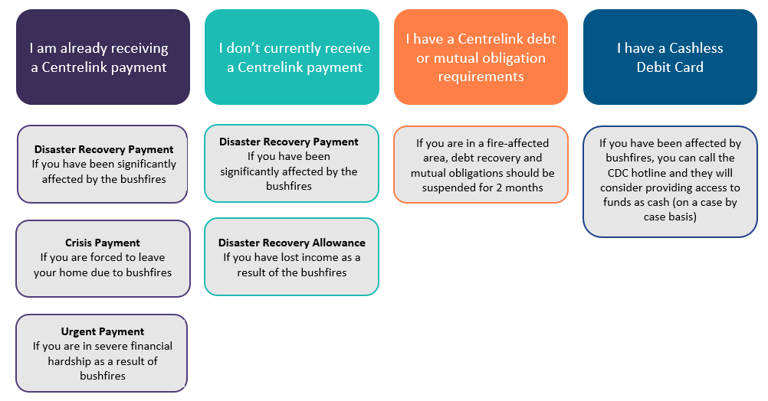

If you need help with any of these issues you can contact your local member centre for free advice at <http://www.nssrn.org.au/services/>.

Overview

This factsheet provides information on what Centrelink can do if you have been affected by the recent bushfires.

This factsheet covers:

* Disaster Recovery Allowance
* Disaster Recovery payment
* Crisis Payment
* Urgent Payment
* Mutual obligations
* Centrelink debts
* Cashless Debit Card



Disaster Recovery Allowance

If you have lost income as a result of the bushfires, you may be able to get Disaster Recovery Allowance.

For more information and a list of fire-affected areas see <https://www.humanservices.gov.au/individuals/help-emergency/bushfires>



To ensure that your claim is processed as quickly as possible you should lodge the claim now, even if you can’t access all the evidence you need, and provide the required information within the next 28 days. Even if the 28 days has passed, you should still provide the information to Centrelink as claims for Disaster Recovery Allowance can be made until 1 July 2020.

You can apply for Disaster Recovery Allowance by calling Centrelink on 180 22 66, completing the [claim form](https://www.humanservices.gov.au/individuals/forms/em195) or going to a service centre. You will need to provide evidence of your loss of income.



Disaster Recovery Allowance is payable for a maximum of 13 weeks. The rate you will receive depends on your circumstances and the maximum rate is the equivalent of Newstart or Youth Allowance.

You cannot claim Disaster Recovery Allowance if you are already receiving a Centrelink payment.

Both Disaster Recovery Allowance and Disaster Recovery Payment are available to New Zealand citizens who are holders of a non-protected Special Category Visa and have paid tax for at least one year in the past three financial years.

If you are having issues applying for Disaster Recovery Allowance or your claim is rejected, you have the right to appeal. It is a good idea to lodge the appeal within 13 weeks of the decision so you can receive full backpayment if you are successful. You can contact your local member centre for free advice on appealing. Your local member centre can be found at <http://www.nssrn.org.au/services/>.



Disaster Recovery Payment

If you have been **significantly affected** by the bushfires, you may be able to get Disaster Recovery Payment.

For more information and a list of fire-affected areas see <https://www.humanservices.gov.au/individuals/help-emergency/bushfires>

“**Significantly affected**” can mean:

* You have been seriously injured
* You’re an immediate family member of an Australian citizen or resident who died in the bushfires
* Your principal place of residence has been destroyed or must be demolished
* The interior of your principal place of residence has sustained major damage
* Damage from the fire has exposed the interior of your principal place of residence to the elements
* Your principal place of residence has been declared structurally unsound
* The interior of your residence has been affected by sewerage contamination
* Any asset or assets on your property worth a total of at least $20,000 have been destroyed or suffered major damage
* You’re the principal carer of a dependent child who has experienced any of the above.

The Disaster Recovery Payment is $1,000 per adult and $800 for each child younger than 16.



You can apply for Disaster Recovery Payment by calling Centrelink on 180 22 66, completing the [claim form](https://www.humanservices.gov.au/individuals/forms/em194) or going to a service centre. You will need to provide evidence that you have been significantly affected.



To ensure that your claim is processed as quickly as possible you should lodge the claim now, even if you can’t access all the evidence you need, and provide the required information within the next 28 days. Even if the 28 days has passed, you should still provide the information to Centrelink as claims for Disaster Recovery Payment can be made until 5 July 2020.





If you are having issues applying for Disaster Recovery Payment or your claim is rejected, you have the right to appeal. It is a good idea to lodge the appeal within 13 weeks of the decision so you can receive full backpayment if you are successful. You can contact your local member centre for free advice on appealing. Your local member centre can be found at <http://www.nssrn.org.au/services/>.

Crisis Payment

If you are already receiving a Centrelink payment and are forced to leave your home due to bushfires, you may be able to access Crisis Payment.

Crisis Payment is a one-off payment equal to one week of whatever payment you are currently receiving from Centrelink.



To be eligible for Crisis Payment you must:

* Be receiving a social security payment, and
* Be in severe financial hardship, and
* **Contact Centrelink within 7 days** from the day you are forced to leave your home due to bushfires, and
* **Lodge a claim for Crisis Payment within 14 days** from the day you contact Centrelink

You can apply for Crisis Payment by submitting the claim form, found [here](https://www.humanservices.gov.au/individuals/enablers/claiming-crisis-payment/30756). You can submit the form online through MyGov, by post or in person at Centrelink. You can also:

* Speak to Centrelink on 132 850
* Make an appointment with a Centrelink social worker on 132 850
* If you are Aboriginal or Torres Strait Islander, you can speak to an Indigenous officer on 136 380
* If you are from a non-English speaking background, you can speak to a Centrelink employee in your preferred language by calling 131 202, or speak to Centrelink through an interpreter by calling 131 450

Urgent Payment

You may be able to access part of your next fortnightly Centrelink payment before your regular payday if you are in severe financial hardship due to exceptional and unforeseen circumstances such as a bushfire. This is not an additional payment but will reduce the amount you receive on your regular payday. The urgent payment will be made from any part of your regular payment that has been accrued. Not all payments can be issued as an urgent payment, such as Family Tax Benefit.



You can apply for Urgent Payment by speaking to Centrelink or using your Centrelink Online Account via MyGov.



Advance Payment

A lump sum payment of part of your future Centrelink payments or Family Tax Benefit may be paid in advance. This is not an additional payment and will be repaid by deductions from your future fortnightly payments. The amount that can be issued will vary depending on the payment you are receiving.



You can apply for Advance Payment online through MyGov or the Express Plus app, by phone, by post or in person by submitting the [Application for Advance Payment](https://www.humanservices.gov.au/individuals/forms/ss352) form.

Mutual Obligations

If you are receiving a Centrelink payment and are required to complete mutual obligations, you may be exempt from your obligations due to the bushfires. Mutual obligations include attending appointments with your job service provider, accepting offers of paid work, attending job interviews, attending training and looking for work.

Between 6 January 2020 and 6 March 2020, all recipients in bushfire-affected Local Government Areas were not required to complete mutual obligations. From 6 March, residents in these areas have to complete mutual obligations unless they have an exemption.

Exemptions may be granted to those who are:

* Volunteering to fight bushfires or assisting with that effort
* Assisting bushfire recovery or rebuilding efforts
* Still displaced as a result of the bushfires
* Unable to travel to an appointment as a result of the bushfires
* Unable to complete job search requirements as a result of damage from the bushfires
* Those whose health continues to be affected by the bushfires
* In any other way hampered from completing their mutual obligations as a result of the bushfires

Evidence is normally required before an exemption can be granted. If you cannot reasonably provide evidence, your request for exemption should still be considered.

You can get an exemption for an initial 13 weeks and apply for an extension later.



If you are having issues getting an exemption, such as your payment being suspended, you can contact your local member centre for free advice. Your local member centre can be found at <http://www.nssrn.org.au/services/>.

Centrelink debts



If you live in a fire-affected area, you were not required to pay back your Centrelink debt from 6 January 2020 to 6 March 2020. Following that period, there has been no announcement of further suspension and normal repayment obligations apply.



If you need advice about repaying your debt, you can contact your local member centre. Your local member centre can be found at <http://www.nssrn.org.au/services/>.

Cashless Debit Card



If you need to access your funds as cash, you can call the Cashless Debit Card hotline on 1800 252 604 and ask them to give you access to your funds.

Bushfire affected callers should receive priority assistance by the Department of Social Services on the hotline.

As the Department of Social Services will be assessing each person’s situation on a case by case basis, it will be important to explain how you have been affected by the bushfires and provide any evidence you might have to show why you need access to funds.



If you are having issues with accessing your funds, you can contact your local member centre for free advice. Your local member centre can be found at <http://www.nssrn.org.au/services/>.



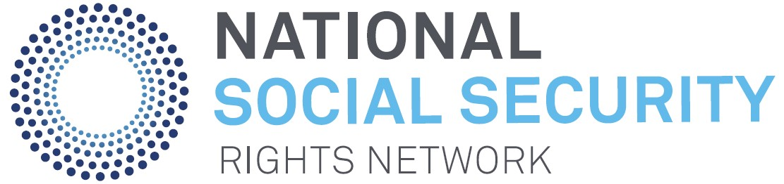

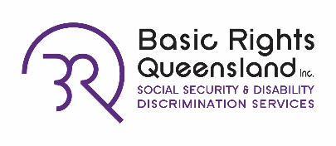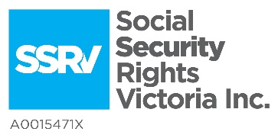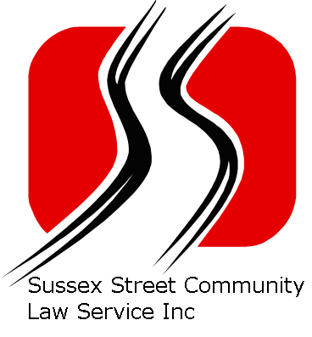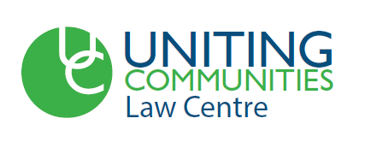

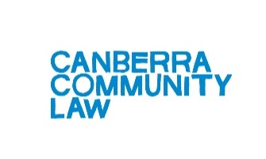

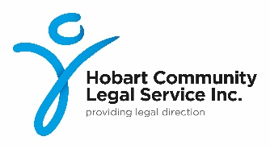



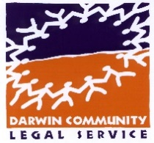



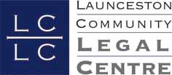

This factsheet was produced with the generous assistance of Wotton + Kearney.

