COVID-19 and Centrelink:
- JobSeeker Payment
- Youth Allowance (job seeker)

This factsheet is about JobSeeker Payment and Youth Allowance (job seeker). It explains the special arrangements currently in place due to COVID-19.
Last updated 06 October 2020
Under these special arrangements you may be eligible for JobSeeker Payment or Youth Allowance (job seeker) If you:
- lose your employment as a permanent employee, or
- are stood down without pay as a permanent employee, or
- lose income as a sole trader, self-employed person, casual worker or contract worker, or
- lose income due to being required to care for someone who is affected by COVID-19.

If you need help with any of these issues you can contact your local member centre for free legal advice. Find your local member centre at http://ejaustralia.org.au/legal-help-centrelink/

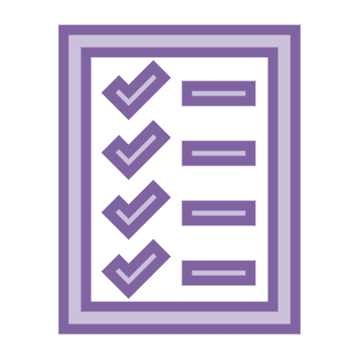
What is JobSeeker Payment?

JobSeeker Payment is the name of the payment that has replaced Newstart Allowance and Sickness Allowance.

To be eligible for JobSeeker Payment you must:

- be between 22 and Age Pension age, and
- meet residence rules, and
- be looking for work, or undertaking approved activities, or be temporarily unable to work due to illness or injury.

What is Youth Allowance (job seeker)?

Youth Allowance (job seeker) is the payment available for young people who are 16 to 21 years of age and looking for work or temporarily unable to work.

What are the special COVID-19 arrangements for these payments?

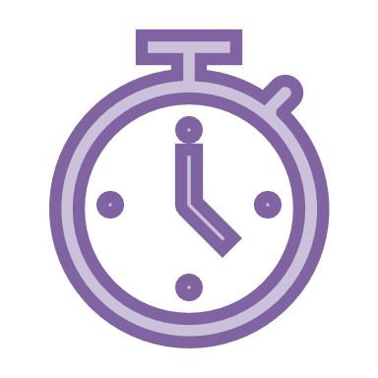
- Waiver of some waiting periods until 31 December 2020 – Some of the waiting periods that would normally apply for JobSeeker Payment and Youth Allowance (job seeker) have been suspended or waived until 31 December 2020. This means that until 31 December 2020 if you claim JobSeeker Payment or Youth Allowance (job seeker):

  - the one week Ordinary Waiting Period, or Seasonal Work Preclusion Period will not be applied
  - the Newly Arrived Residents Waiting Period (NARWP) will be temporarily waived. Unless the Government further extends the special COVID-19 arrangements, you will be required to serve any remaining NARWP from 1 January 2021

- The Liquid Assets Waiting Period – this waiting period has been reintroduced for new claims lodged on or after 25 September 2020.

- Income Maintenance Periods and Compensation Preclusion periods – these waiting periods continue to apply, with no changes.

Income tests – JobSeeker Payment and Youth Allowance (job seeker) are income-tested. Income test thresholds and the assessment of income over these thresholds depend on your age, whether you are single or a member of a couple, and whether you have dependent children. For information about the income tests applying from 25 September 2020 under the special coronavirus arrangements see - https://www.servicesaustralia.gov.au/individuals/services/centrelink/jobseeker-payment/how-much-you-can-get/income-and-asset-limits#a1

- Assets test – The JobSeeker Payment assets test was reintroduced from 25 September 2020. Assets test thresholds depend on whether you are single or a member of a couple, and on whether you own your home. The value of your home property is exempt from assessment. For information about the assets test see https://www.servicesaustralia.gov.au/individuals/services/centrelink/jobseeker-payment/how-much-you-can-get/income-and-asset-limits#a2

- Coronavirus Supplement – JobSeeker Payment and Youth Allowance (job seeker) recipients currently receive the temporary Coronavirus Supplement. From 25 September 2020 the Coronavirus Supplement reduced to $250 per fortnight, and will continue to be paid at this rate until 31 December 2020. The Supplement is paid into your bank account in addition to your fortnightly income-tested entitlement.

- Mutual obligations – Mutual obligation requirements returned from 28 September, with the exception of Victoria where activity requirements remain on hold. Your mutual obligations are listed in your Job Plan or Participation Plan. If you are unable to meet the requirements (for example due to being required to self-isolate, illness, domestic violence or a family crisis), you can seek an exemption. People who are the principal carers of a dependent child, people with a partial work capacity and mature age job seekers may have reduced activity requirements. For up to date information about mutual obligation requirements see https://jobsearch.gov.au/covid-19-information

There are also activity requirements for people outside Victoria, including:
- Attending scheduled phone or online appointments with your employment service provider or jobseeker contact centre
- Applying for up to 8 jobs a month (this can be reduced for principal carers, people with a partial work capacity, people in regions where unemployment is high, and people with other barriers to employment)
- Accepting ‘suitable’ job offers (you can reject a job offer if you have a ‘reasonable excuse’).
- Participating in other activities such as vocational training, literacy training, part-time employment, voluntary work, Work for the Dole.

Penalties - if you do not meet these requirements (e.g. miss a provider appointment or activity, or don’t report your job searches on time) your next payment may be suspended until you re-engage. You may also have a demerit point applied if you did not have ‘reasonable excuse’ for not meeting the requirement. If you have too many demerit points, this can lead to financial penalties including suspension of payment for up to four weeks. Centrelink must give you an opportunity to explain the reasons for not meeting the requirement before financial penalties are applied. If you reject a ‘suitable’ job offer without a ‘reasonable excuse’, Centrelink may cancel your payment and impose a four-week waiting period if you re-apply.

When will payment start?

Although it may take some time for Centrelink to process your claim, payment should date back to the date your ‘intention to claim’ was lodged (online, over the phone or in person) – as long as you lodge your claim within 14 days of advising Centrelink of your intention to claim.

Leave entitlements can affect the date from which payment can be made. It is important to register an intention to claim JobSeeker Payment or Youth Allowance (job seeker) as soon as possible, even if you are receiving leave entitlements, so your JobSeeker Payment can commence when they finish.

Do I still need to report income under the temporary arrangements?

Yes.

If you do not report changes to your income, or your partner’s income,
you may incur a debt.

What is Crisis Payment? Who can get it?

You may be eligible for a one-off Crisis Payment if you are in severe financial hardship and you are receiving a Centrelink payment such as JobSeeker Payment or Youth Allowance. You can claim Crisis Payment if you are in crisis for any reason, including if you need to escape domestic or family violence, or if you need to:

- be in quarantine or self-isolation as a result of advice from, or a requirement made by, the government or a health professional regarding COVID-19, or
- care for an immediate family member or a member of your household who is required to be in quarantine or self-isolation.
You must contact Centrelink within 14 days after starting the quarantine or self-isolation period and let them know about your intention to claim. You must then make a claim within 14 days after the contact day.

How do I apply for a payment?

For a step by step guide on claiming payments, see our factsheet ‘Claiming Centrelink payments during COVID-19’.

When you are applying for JobSeeker Payment and Youth Allowance (job seeker), you will be required to:

- Make an initial declaration about your identity, residency status and income
- If you are a worker, make a declaration that you have been made redundant or had your hours reduced (including to zero) as a result of the economic downturn due to COVID-19
- If you are a sole trader, make a declaration that your business has been suspended or that turnover has reduced significantly

If you pay rent, you should also declare the amount you pay to qualify for Rent Assistance.

What if my claim is rejected? What if a penalty is applied?

If your claim is rejected, or your payment is suspended or cancelled, you have the right to have the decision reviewed by an Authorised Review Officer, and then the right to appeal to the Administrative Appeals Tribunal. Reviews and appeals are often successful. If you lodge the appeal within 13 weeks of the decision you can receive full back payment if you are successful.

You can seek review of a decision by:

- Phoning or visiting Centrelink
- Completing a form called ‘Review of Decision’ and returning it to Centrelink. It is important to appeal within 13 weeks of receiving the original decision in writing to ensure back payment.

For more information read this factsheet: Appealing a Centrelink Decision

Legal help

Although it’s not necessary, it’s a good idea to get legal advice before appealing.

Find specialist legal help in your area

For all general and media inquiries contact eo@ejaustralia.org.au or call 0448007201.

Copyright © 2020 Economic Justice Australia. Design by UTS Shopfront.

This factsheet does not constitute legal advice.
Please contact any of our member centres if you wish to obtain free legal advice. Find your closest member centre at www.ejaustralia.org.au

