COVID-19 and Centrelink:
- JobSeeker Payment
- Youth Allowance (job seeker)

This factsheet is about JobSeeker Payment and Youth Allowance (job seeker). It explains the special arrangements in place due to COVID-19, including additional payments, changes to waiting periods, and changes to income and assets testing.
Last updated 24 July 2020
Under these special arrangements you may be eligible for JobSeeker Payment or Youth Allowance (job seeker) If you:
- lose your employment as a permanent employee, or
- are stood down without pay as a permanent employee, or
- lose income as a sole trader, self-employed person, casual worker or contract worker, or
- lose income due to being required to care for someone who is affected by COVID-19.

If you need help with any of these issues you can contact your local member centre for free legal advice. Find your local member centre at http://ejaustralia.org.au/legal-help-centrelink/

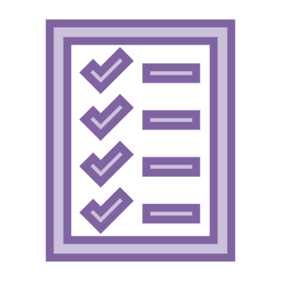
What is JobSeeker Payment?

JobSeeker Payment is the name of the payment that has replaced Newstart Allowance and Sickness Allowance as part of the special arrangements to deal with COVID-19.

To be eligible for JobSeeker Payment you must:

- be between 22 and Age Pension age, and
- meet residence rules, and
- be looking for work, or undertaking approved activities, or be temporarily unable to work due to illness or injury.

What is Youth Allowance (job seeker)?

Youth Allowance (job seeker) is the payment available for young people who are 16 to 21 years of age and looking for work or temporarily unable to work.

What are the special COVID-19 arrangements for these payments?

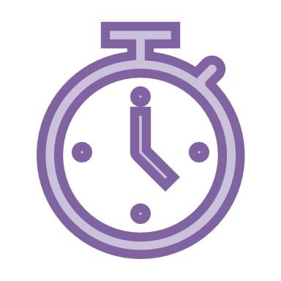
- Waiver of some waiting periods until 31 December 2020 – Some of the waiting periods that would normally apply for JobSeeker Payment and Youth Allowance (job seeker) have been suspended or waived. The Government has announced that these waiting periods will remain suspended until 31 December 2020. This means that until 31 December 2020 if you claim JobSeeker Payment or Youth Allowance (job seeker):

  - the one week Ordinary Waiting Period, or Seasonal Work Preclusion Period will not be applied.
  - the Newly Arrived Residents Waiting Period (NARWP) will be temporarily waived. Unless the Government further extends the special COVID-19 arrangements, you will be required to serve any remaining NARWP from 1 January 2021.

- The Liquid Assets Waiting Period – this waiting period has been waived until 24 September 2020. It will be reintroduced for new claims lodged on or after 25 September 2020.

- Income Maintenance Periods and Compensation Preclusion periods – these waiting periods continue to apply, with no changes.

- Income tests – JobSeeker Payment and Youth Allowance (job seeker) are income-tested. This means that your rate of payments depends on your own income and if you have a partner, their income is assessed too. Under the temporary COVID-19 arrangements, the income tests have changed:

  - Until 24 September 2020, the income test free area for JobSeeker Payment is $106 per fortnight for personal income i.e. your own income. The income test free area for Youth Allowance (job seeker) for personal income is $143 per fortnight. This means that personal income under these amounts will not affect your payment rate.
  - From 25 September 2020 the income test free area for both JobSeeker Payment and Youth Allowance (job seeker) will increase to $300 per fortnight for personal income. The fortnightly rate of payment will reduce by 60 cents for every dollar of personal income over $300.
  - The income test for assessing the income of a person’s partner has also temporarily changed for JobSeeker Payment but not for Youth Allowance. For more information about the partner income test see the Services Australia website here. The Government has announced changes to the partner income test from 25 September 2020 - these changes to partner income testing will not apply to Youth Allowance.

- Assets test – Under the temporary arrangements assets are not currently taken into account for JobSeeker Payment. The JobSeeker Payment assets test will be reintroduced from 25 September 2020 – the same assets test that previously applied to Newstart Allowance.

- Coronavirus Supplement – JobSeeker Payment and Youth Allowance (job seeker) recipients currently receive the temporary Coronavirus Supplement. The Coronavirus Supplement is currently $550 per fortnight. The Government has announced that from 25 September 2020 the Coronavirus Supplement will reduce to $250 per fortnight, and will continue to be paid until 31 December 2020. The Supplement is paid into your bank account in addition to your fortnightly income-tested entitlement.

- The First Economic Support Payment ($750) - The first Economic Support Payment was paid to people who were entitled to JobSeeker Payment, Youth Allowance and other eligible payments between 12 March and 13 April 2020. For people with claims that have not yet been processed, the first Economic Support Payment will be paid when the claim is granted. The Second Economic Support Payment ($750), paid in July, is not payable to people receiving the Coronavirus Supplement. This means that it is not payable to JobSeeker Payment and Youth Allowance recipients.

- Mutual obligations – Mutual obligations have been relaxed under the temporary COVID-19 special arrangements but are being gradually reintroduced. The Government has announced changes that will apply from 4 August 2020:

  - JobSeeker Payment and Youth Allowance (job seeker) recipients must be willing to accept any offer of suitable paid work. Penalties will apply for refusal to accept a suitable job offer without a reasonable excuse.
  - JobSeeker Payment recipients who have an Employment Service Provider or who are with the Online Employment Service will be required to undertake at least four job searches each month, unless required to undertake training or other activities. Job seekers will not be penalised or have payment suspended for failing to meet job search requirements - penalties should only apply for refusal of a suitable job without a reasonable excuse.
  - Special circumstances exemptions from mutual obligations will continue to be available.
  - Sole traders and people who are self-employed will continue to be exempt from mutual obligation requirements to enable businesses to be re-established.

When will payment start?

Although it may take some time for Centrelink to process your claim, payment should date back to the date your ‘intention to claim’ was lodged (online, over the phone or in person) – as long as you lodge your claim within 14 days of advising Centrelink of your intention to claim.

Leave entitlements can affect the date from which payment can be made. It is important to register an intention to claim JobSeeker Payment or Youth Allowance (job seeker) as soon as possible, even if you are receiving leave entitlements, so your JobSeeker Payment can commence when they finish.

Do I still need to report income under the temporary arrangements?

Yes.

If you do not report changes to your or your partner’s income you may incur a debt.

What is Crisis Payment? Who can get it?

You may be eligible for a one-off Crisis Payment if you are in severe financial hardship and you are receiving a Centrelink payment such as JobSeeker Payment or Youth Allowance. You can claim Crisis Payment if you are in crisis for any reason, including if you need to escape domestic or family violence, or if you need to:

- be in quarantine or self-isolation as a result of advice from, or a requirement made by, the government or a health professional regarding COVID-19, or
- care for an immediate family member or a member of your household who is required to be in quarantine or self-isolation.
You must contact Centrelink within 14 days after starting the quarantine or self-isolation period and let them know about your intention to claim. You must then make a claim within 14 days after the contact day.

How do I apply for a payment?

For a step by step guide on claiming payments, see our factsheet ‘Claiming Centrelink payments during COVID-19’.

When you are applying for JobSeeker Payment and Youth Allowance (job seeker), you will be required to:

- Make an initial declaration about your identity, residency status and income
- If you are a worker, make a declaration that you have been made redundant or had your hours reduced (including to zero) as a result of the economic downturn due to COVID-19
- If you are a sole trader, make a declaration that your business has been suspended or that turnover has reduced significantly

If you pay rent, you should also declare the amount you pay to qualify for Rent Assistance.

What if my claim is rejected or I have a problem getting my payment?

If your claim is rejected, you have the right to have the decision reviewed by an Authorised Review Officer, and then the right to appeal to the Administrative Appeals Tribunal. Reviews and appeals are often successful. If you lodge the appeal within 13 weeks of the decision you can receive full back payment if you are successful.

You can seek review of a decision by:

- Phoning or visiting Centrelink
- Completing a form called ‘Review of Decision’ and returning it to Centrelink. It is important to appeal within 13 weeks of receiving the original decision in writing to ensure back payment.

For more information read this factsheet: Appealing a Centrelink Decision

Legal help

Although it’s not necessary, it’s a good idea to get legal advice before appealing.

Find specialist legal help in your area

For all general and media inquiries contact eo@ejaustralia.org.au or call 0448007201.

Copyright © 2020 Economic Justice Australia. Design by UTS Shopfront.

This factsheet does not constitute legal advice.
Please contact any of our member centres if you wish to obtain free legal advice. Find your closest member centre at www.ejaustralia.org.au

