MEDICAL EXEMPTIONS FROM MUTUAL OBLIGATIONS

Last updated July 2023

This factsheet provides information on obtaining medical exemptions from your mutual obligation requirements.

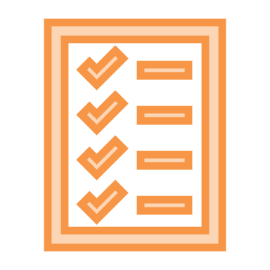
Mutual obligations apply to recipients of Jobseeker Payment, Youth Allowance, Parenting Payment and Special Benefit. Obligations can include attending appointments with your Employment Services Provider, looking for and accepting work, and other activities such as training.

This factsheet covers:

- How can I get a medical exemption from my mutual obligation requirements?
- How long will the exemption last?
- What can I do if my condition is likely to affect my capacity for work for longer than 2 years?
- What can I do if my application for an exemption is rejected?
- Negotiating new mutual obligations
- What can I do if my condition gets worse after I lodged my medical certificate?
- Where can I get help?

How can I get a medical exemption from my mutual obligation requirements?
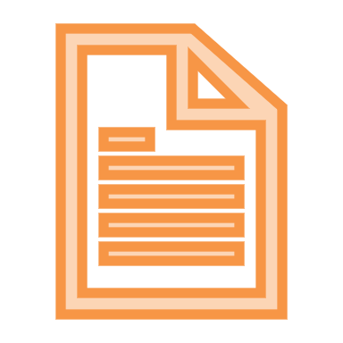
If you have a medical or psychiatric condition that temporarily prevents you from being able to work for 8 or more hours a week or complete mutual obligation activities, you may be able to get a medical exemption.

- The condition can be physical or it can be a mental illness
- The condition may be new - like a broken arm or the flu; or an exacerbation or flare-up of an existing condition – such as asthma or epilepsy; or an episode of a psychiatric condition - such as clinical depression or schizophrenia.

To apply for an exemption, ask your doctor to fill in a Centrelink medical certificate form. The certificate should say how long you will be incapacitated for, and why. Your doctor should lodge this form through the online portal and give you a copy of the completed form. You should give your copy to Centrelink and ask for an exemption from mutual obligations.

How long will the exemption last?

Centrelink generally gives an exemption for the period of incapacity noted by the GP on the medical certificate. The maximum time for an exemption is usually 13 weeks.

If you are still unfit for at least 8 hours work or mutual obligations a week after 13 weeks, you can apply for a further exemption by submitting a new medical certificate.

If you are pregnant, you will be given an exemption from mutual obligation requirements from at least 6 weeks before your due date, and until 6 weeks after the baby’s birth. You can ask for

an exemption from earlier than this or for a longer period after the baby’s birth, with a medical certificate.

If you have a serious medical or psychiatric condition, Centrelink may give you an exemption for longer than 13 weeks without requiring additional medical certificates. Serious conditions include:

- Cancer
- A severe stroke
- A brain injury
- Serious burns
- A serious physical injury requiring a long period of recovery
- Severe mental health conditions.

If you are given an exemption from mutual obligations, Centrelink may refer you for an assessment by your Employment Services Provider. This is to work out whether your ongoing mutual obligation requirements are still appropriate. Your mutual obligation requirements should take into account any medical conditions you have.

Negotiating new mutual obligations

If you do not have a medical certificate but you would like your medical or mental health condition, or disability, to be taken into account for your mutual obligation requirements, you can ask your employment services provider to revise your requirements.

If you have tried to re-negotiate your mutual obligations and you think that you have been treated unfairly, you can ask to change providers.

You can also contact the Department of Employment National Customer Service Line on 1800 805 260 to make a complaint about your provider.

What can I do if my condition is likely to affect my capacity for work for longer than 2 years?

If your condition is likely to prevent you from working for more than 15 hours a week for at least 2 years, consider applying for Disability Support Pension (DSP). You can be paid JobSeeker Payment without mutual obligations while your DSP application is being assessed.

See our factsheet on Disability Support Pension for more information on applying.

What can I do if my application for an exemption is rejected?

If your application for an exemption from mutual obligations is rejected, you have the right to appeal this decision. See our factsheet on Appealing to Centrelink for more information on this process. You should ask for a review by a Centrelink Authorised Review Officer ASAP. You need to ask for a review within 13 weeks of being notified about the decision to get any backpay.

It is a good idea to ask Centrelink why you were not given an exemption. If you can, ask your doctor to give you a brief letter to Centrelink clearing up any misunderstanding.

While you are waiting for the decision to be reviewed you may need to lodge another medical certificate covering the period after your previous certificate ended.

What can I do if my condition gets worse after I lodged my medical certificate?
If your condition gets worse after submitting your medical certificate, you should ask your doctor for a new medical certificate that explains this.

Where can I get help?
You can get free legal advice from your closest member centre which can be found at http://www.ejaustralia.org.au/legal-help-centrelink/.
This factsheet does not constitute legal advice.
Please contact any of our member centres if you wish to obtain free legal advice. Find your closest member centre at www.ejaustralia.org.au

