Newly Arrived Residents Waiting Period

Last updated July 2023

This factsheet provides information only about the newly arrived residents waiting period

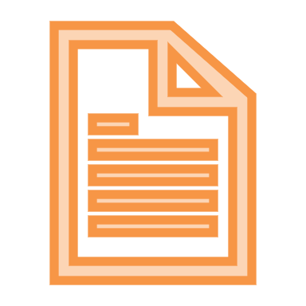
To receive Centrelink income support payments, you must generally have lived in Australia for a certain number of years - as a permanent resident, or as the holder of a specified class of long-stay temporary visa. Some people are exempt from these residential waiting periods, including refugees.

The residential waiting period for non-pension Centrelink payments - such as JobSeeker Payment, Youth Allowance, and Parenting Payment - is called the “newly arrived residents waiting period”. In this factsheet we call this the “NARWP”.

The NARWP does not apply to pensions such as Age Pension and Disability Support Pension. These pensions have residential waiting periods but they operate differently.

Who may be subject to a NARWP?

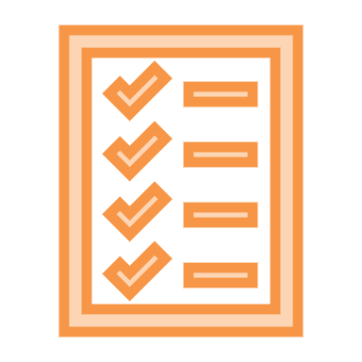
A NARWP may apply to people who hold a permanent visa or a specified subclass of temporary visa (such as a partner visa).

What about New Zealanders?

New Zealand citizens living in Australia are subject to different rules – see here: https://www.servicesaustralia.gov.au/individuals/topics/new-zealand-citizens-claiming-payments-australia/30721

Who is exempt from the NARWP?

You may be exempt from a NARWP if you are:
- an Australian citizen
- a refugee or former refugee
- a holder of a specified visa subclass (for certain payments)
- a family member of a refugee or humanitarian migrant.
Read more about NARWP exemptions here: https://www.servicesaustralia.gov.au/individuals/topics/exemptions-newly-arrived-residents-waiting-period/46481

What payments are subject to the NARWP? How long is the NARWP?

A 4 year NARWP can apply to:
- Austudy
- JobSeeker Payment
- Parenting Payment single and partnered
- Special Benefit (may be exempt if in hardship)
- Youth Allowance.

A 2 year NARWP can apply to:
- Carer Payment
- Dad and Partner Pay
- Parental Leave Pay
- Parenting Payment single and partnered (if you are an Australian citizen and have started living in Australia for the first time).

Read more here: https://www.servicesaustralia.gov.au/individuals/topics/newly-arrived-residents-waiting-period/30726#a1

Where can I get advice and assistance?

If you are experiencing problems applying for Special Benefit, you can contact your nearest specialist community legal centre for help. See here.

If your Special Benefit claim is rejected you can appeal. See our Appeals Factsheet here.

This factsheet does not constitute legal advice.
Please contact any of our member centres if you wish to obtain free legal advice. Find your closest member centre at www.ejaustralia.org.au

